

CSE-326

[This Photo](https://en.wikipedia.org/wiki/File:Soccer_ball.svg) by Unknown Author is licensed under [CC BY-SA](https://creativecommons.org/licenses/by-sa/3.0/)

FINAL REPORT

**Restaurant Website**

**SUBMITTED TO**: MUBASHIR FAROOQ

(ASSISTANT PROFESSOR)

**SECTION**:K20RB

**GROUP MEMBERS**:

**NAME**  **ROLL NO**. **REG.NO.**

Karishma Moond 87 12016446

Chaman Yadav 86 12016373

FooDelicious

Introduction...

* From swanky upscale restaurants to the cosiest hidden gems serving the most incredible food, FooDelicious covers it all. Find your next meal.
* We have used basically, HTML5 and CSS3 for designing, styling and giving a proper content to our website and have used basic JavaScript to make a functionality on Login page and also to home page for basic function like smooth scroll, Slider.
* We have divided our “FooDelicious” website into following modules/sections: -
* Home
* About
* Menu
* Dinning_area
* About_Us
* Contact Us

Flow Of links

*The Main

Home

Page

Page of

Website.

Login

Page

*Login To

Have an entry

On next page.

Different Modules of Website.

1. Home Page

* This module of website consists of Restaurant Name on the left-hand side and the following navigation bars: HOME, ABOUT , MENU,DINNING_AREA, ABOUT US AND CONTACT US.

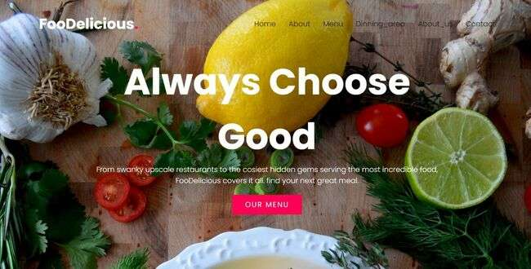

* When the client clicks on any of the following navigation bar the page will be directed to that specific module of specific ID.
* A Special and silent feature of website and one interesting onclick gesture will redirect you to a new Secret page.

1. About US.

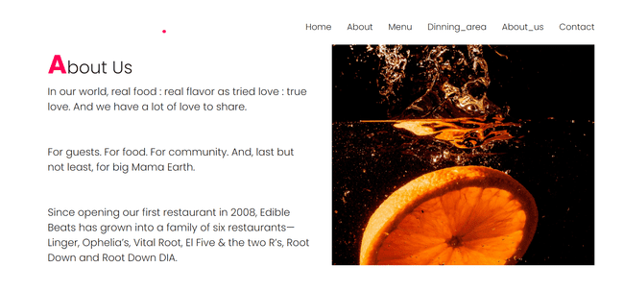

* The Basic About page consists of divisions contains png files and text section.

1. MENU

* The basic CSS is used to for alignment and background attachment is fixed used here.
* This contains the menu with 6.png And a VIEW ALL CLICKABLE BUTTON.
* On clicking on VIEW ALL BUTTON it will redirect you to home page.
* A slider JavaScript file is linked to this section to have such effect of slider.
* By changing the value of this variable, we can easily change the alignment and style of slider to have a different view.

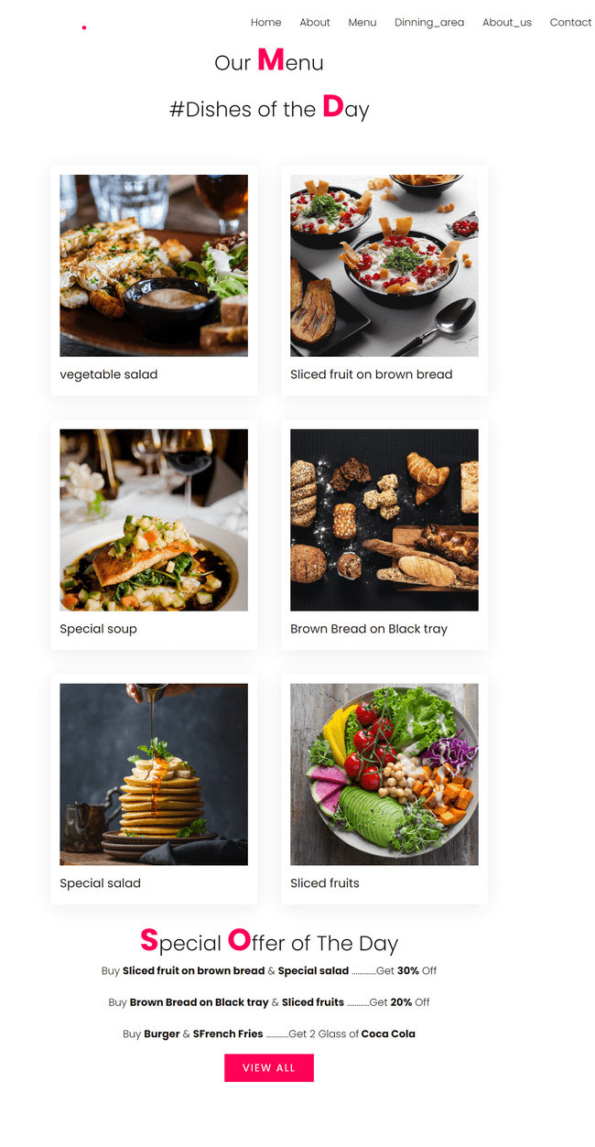4. Dinning_area

* This section contains the data and features all restaurant available on website.
* Basic CSS is used to have such effect of different divisions.
* services is ID given is html code and have different col-md class for divisions.
* The Basic About page consists of divisions contains png files and text section .

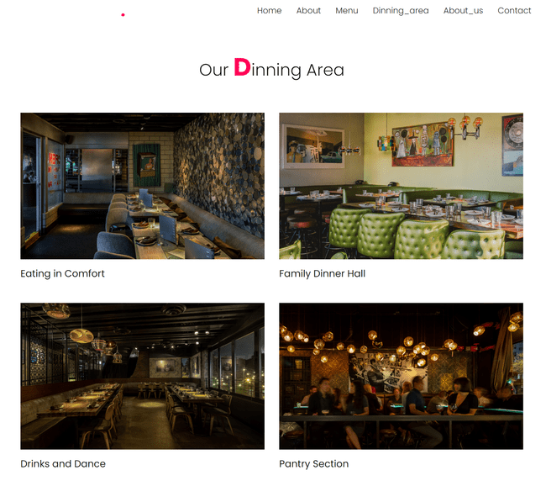

* Here two cards (basically a two divisions) are designed to take the information of developers.

5. About Us

* Two divisions are of grid type.
* The linear gradient hover effect is used there to have such awesome effect with little transition.

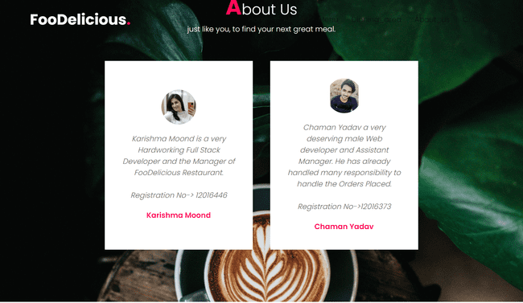

6. Contact us

* Four divisions are made for four sections contain A small intro, features, Quick contact, Follow Us.
* Features contains the link of Login, Sign-in, (Redirect tologin section) and back to Home (which redirect back to home page).
* Login and sign-in links with Login page for login and sign-in
* Quick-contact division contains the Phone numbers of developers.
* Follow Us division links the LinkedIn page of developers for further contact.
* The copyright of Developers.

